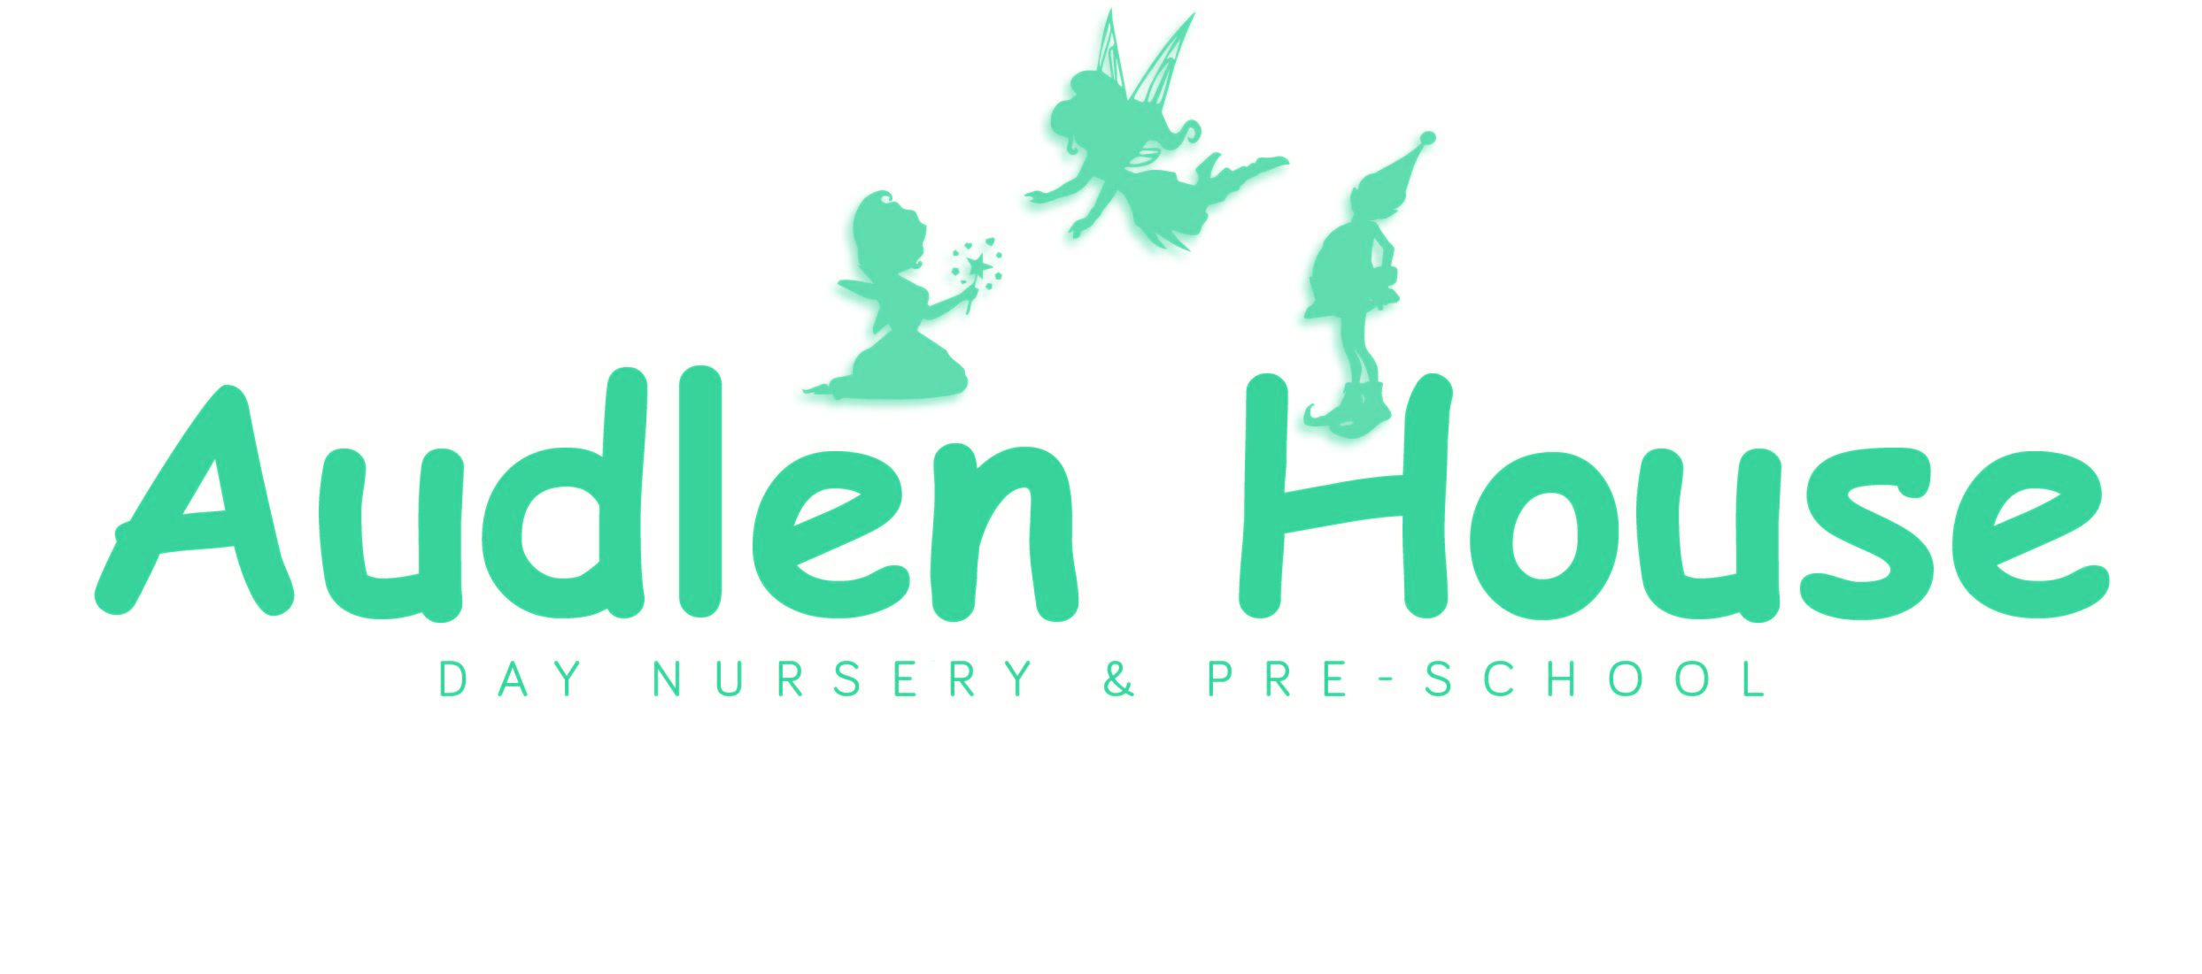

**131-133 Station Road**

**Thatcham**

**Berkshire**

**RG19 4QH**

**Telephone: 01635 876667**

**Email:** [**office@audlen-house-nursery.co.uk**](mailto:office@audlen-house-nursery.co.uk)

**Ofsted Number 2793978**

[**www.audlen-house-nursery.co.uk**](http://www.audlen-house-nursery.co.uk)

    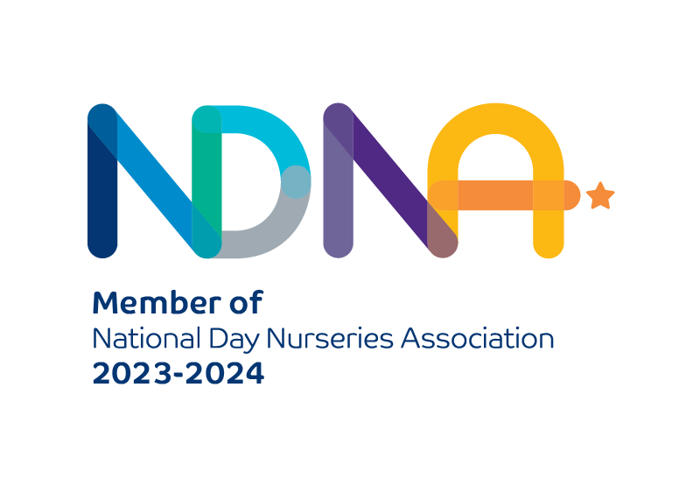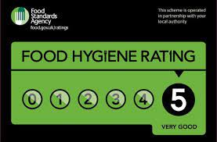

Updated March 2025

**Welcome**

Audlen House Day Nursery has been an outstanding nursery, as rated by Ofsted, since February 2014.

We are conveniently located near to the Train Station and the A4 making accessibility to the surrounding areas much easier for those working and living in Thatcham.

Audlen House Day Nursery opens at 8am and closes at 6pm from Monday to Friday, except on Public Holidays and the days between Christmas and the New Year and Christmas Eve if it falls on a nursery opening day.

We offer various session times which cover mornings, afternoons, school days or full days either all year round or for term time only attendance. Our term dates are closely in line with West Berkshire Council’s School funded Term Dates.

The nursery cares for 58 children aged 0 – 5 years of age.

Please feel free to make an appointment to come and view our facilities and discuss your childcare requirements.

**A Brief History and Background**

Audlen House Day Nursery opened in January 2002 and provides care and education to 58 children aged from 3 months to 4+ at any one time. Audlen House offers a high standard of quality childcare and education to provide the best start for your child.

The children are cared for in their own age-related playrooms. 0 -2-year-olds attend the Fairies group, 2 -3 year olds attend Pixies group and 3 – 5 year olds attend Elves group.

As well as the separate playrooms and sleep rooms, we provide separate age-appropriate outdoor play areas containing age-appropriate toys and equipment for the under 2’s and 2-3’s and the 3-5’s.

Our hope is that all our combined efforts will make a positive difference in the life of a child.

*‘If a child can’t learn in the way that we teach, then we must teach in a way that he can learn’*

*Ivor Lovass PHD*

**The Aims of Audlen House**

We aim to provide an environment in which the babies and children are happy, cared for and given a wide range of activities suited to their individual developmental stages and needs. Working as a team we will encourage the babies and children to be happy, confident, independent individuals who are polite, respectful of others and their surroundings and have the necessary skills to enable them to develop further i.e. the ability to listen, to concentrate and most importantly to enjoy learning.

**Behaviour Policy**

Through positive reinforcement of good behaviour, encouragement and praise, all babies and children will be taught a sense of right and wrong, to have mutual respect, develop caring personal relationships and to have good manners. It will however be inevitable that during the learning process of having relationships that the children will have occasional conflicts but these will be approached in a firm, kind and consistent manner by all staff, having taken account of the understanding level of the children concerned. We uphold the ‘NO SMACKING POLICY’ and the staff at Audlen House will never use methods of discipline that result in physical, nutritional or emotional injury.

**Equal Opportunities**

# All of the babies and children at Audlen House will be treated with kindness and consideration and be recognised as individuals with differing needs. Individual needs will be catered for within the scope of the nursery setting and in so doing all babies, children and adults will be given equality of opportunity having regard for disability, ethnic origin, medical condition, gender, special educational need, religion, age, sole parenthood or marital status.

# Special needs

# As part of the setting's policy to make sure that its provision meets the needs of each individual child, we take account of any special needs a child may have, please see our ‘local offer’ for further information.

**Parental Involvement**

Parents and carers are invited to spend some baby or child during the first settling in session and all parents and carers will be kept up to date with any information concerning their child through direct communication from staff, progress reports, Parents Consultations, Open Days, newsletters and messages on Tapestry. We are also happy to spend time answering any questions you may have or special requests you wish to have considered and you can make an appointment to speak to a senior member of staff to discuss matters in greater detail at a time more convenient to both. A full copy of our Policies and Procedures is available in the office should you wish to read them.

**Admissions Policy**

Nursery places are subject to availability and staffing levels with equality of access to places as outlined in our Equal Opportunities Policy. When a place becomes available within a suitable age group the baby or child at the top of the list will be offered a place according to the start date required. Priority will be given to full time places and in order to maintain a family atmosphere, siblings of children already attending will take priority where possible.

Once a place has been registered and the place confirmed we will arrange a couple of short visits, at no cost, usually in the week before starting to enable parents to exchange information with the staff about their baby or child and for the parents and staff to get to know each other.

**Dietary Requirements**

Audlen House makes snacks and meals a social time at which children and adults eat together. We plan the menus for snacks and meals so that they provide the children with healthy and nutritious food. All our meals are prepared daily and cooked on the premises by our cook, we currently hold 5 star environmental health rating. We have a nutritionally balanced menu plan which is updated seasonally. We incorporate a wide range of meals with influences from around the world. We endeavour to cater for any dietary needs but owing to concerns with regard to allergies we can only cater within the scope of the nursery with respect to the severity of the allergy and whether any additional special precautions should be taken. We do not knowingly allow nuts, especially peanuts onto the premises and ask that parents/carers and staff also respect this. All babies follow home routines and parents/carers and staff will liaise closely when weaning is undertaken and new foods introduced. We provide readymade formula milk until the child’s 1st birthday or earlier if you advise us no longer on formula. Breast milk if provided by a baby’s mother can be given too. Please note we cannot accept any food or drinks from home for your baby / child for their consumption throughout their nursery day.

On your child’s birthday if you would like to, you are welcome to provide shop bought cupcakes in the original packaging. Please check with your child’s group for any dietary needs that may need to be catered for.

**Child Protection and Safeguarding Children**

The welfare of the babies and children is paramount. We have a duty of care to all the babies and children within our setting and will, if necessary, keep a written record of any incidents or concerns that we have. Any concerns we may have about a baby or child’s welfare will be passed to the relevant authorities.

**Staffing and Supervision**

# At Audlen House we maintain the ratio of adults to children in the setting that is set through the Safeguarding and Welfare Requirements. This helps us to:

# give time and attention to each child;

# talk with the children about their interests and activities;

# help children to experience and benefit from the activities we provide; and

# allow the children to explore and be adventurous in safety.

The babies and children will be supervised at all times, both indoors and outdoors. All the staff have a relevant childcare qualification or are working towards gaining one. In addition, most of the staff hold First Aid and Food Hygiene qualifications and regularly attend courses to further their personal development and extend their knowledge into specialist areas.

The staffing ratios are as follows:

0 – 2 years = 1 staff:3 babies Fairies Group

2 – 3 years = 1 staff:5 children Pixies Group

3 – 5 years = 1 staff:8 children Elves Group

# Key persons and your child

# Our setting uses a key person approach. This means that each member of staff has a group of children for whom she/he is particularly responsible. Your child's key person, alongside the Senior, will be the person who works with you to make sure that what we provide is right for your child's particular needs and interests. When your child first starts at the setting, she/he will help your child to settle and throughout your child's time at the setting, she/he will help your child to benefit from the setting's activities.

**Security**

Entry to the nursery is via an intercom system. Parents, carers and visitors are requested to press the buzzer to inform us of their arrival at nursery, a member of staff will come to greet them at the door.

**Car Park**

The car park gets very busy at times so please try not to take longer than necessary when dropping off or collecting your child to allow others access also. **ALWAYS** drive with extreme caution in the car park and be aware of children at all times in the car park. All cars are parked at your own risk. For your child’s safety gates must be kept closed at all times, please to don’t allow your child to assist you in opening or closing the gates themselves.

**Disruption to Opening Times**

# On very rare occasions the nursery has had to close or amend the opening times for example in adverse weather conditions, Covid-19 pandemic government guidance for isolation which for the sake of safeguarding the babies, children, parents/carers and staff has been undertaken. Parents/Carers are informed of such an occurrence as early as is possibly feasible, normally by email. Nursery fees will still be charged in full in such instances and no refunds will be given.

# Our Nursery Day

# Audlen House organises the day so that children can take part in a variety of child-chosen and adult-led activities. These take account of children's changing energy levels throughout the day. Audlen House caters for children's individual needs for rest and quiet activities during the day. Outdoor activities contribute to children's health, their physical development and their knowledge of the world around them. The children have opportunities to take part in cooking sessions, Music & Movement Classes, Boogie Mites and Sing and Sign sessions.

# Children's development and learning

# The provision for children's development and learning is guided by The Early Years Foundation Stage (DfE 2023). Our provision reflects the four guiding themes and principles of the Early Years Foundation Stage.

# *A Unique Child* : Every child is a unique child who is constantly learning and can be resilient, capable, confident and self assured.

# *Positive Relationships*: Children learn to be strong and independent through positive relationships.

# *Enabling Environments* : Children learn and develop well in enabling environments, in which their experiences respond to their individual needs and there is a strong partnership between practitioners, parents and carers.

# *Learning and Development* : Children develop and learn in different ways. the framework covers the education and care of all children in early years provision including children with special educational needs and disabilities.

# How we provide for development and learning

# Children start to learn about the world around them from the moment they are born. The care and education offered by our setting helps children to continue to do this by providing all of the children with interesting activities that are appropriate for their age and stage of development.

# The Areas of Development and Learning comprise

# Prime Areas- Personal, social and emotional development; Physical development; Communication and language

# Specific Areas- Literacy, Mathematics, Understanding the world, Expressive arts and design

# For each area, the level of progress children should be expected to have attained by the end of the Early Years Foundation Stage is defined by the Early Learning Goals. These goals state what it is expected that children will know and be able to do by the end of the reception year of their education.

# The ‘Development Matters’ and ‘Birth to 5’ non statutory guidance sets out the likely stages of progress a child makes along their learning journey towards the early learning goals. Our setting has regard to these matters when we assess children and plan for their learning.

# Personal, social and emotional development

# Self regulation Managing Self Building relationships

# Physical development

# Gross Motor Skills Fine Motor Skills

# Communication and language

# Listening, attention & understanding Speaking

# Literacy

# Comprehension Word Reading Writing

# Mathematics

# Number Numerical Patterns

# Understanding the world

Past and Present People, Culture and Communities The Natural World

# Expressive arts and design

# Creating with Material Being Imaginative and Expressive

# Our approach to learning and development and assessment

# *Learning through play*

# Play helps young children to learn and develop through doing and talking, which research has shown to be the means by which young children learn to think. Audlen House uses the Early Years Foundation Stage ‘Development Matters’ and Birth to 5 Matters ’ guidance to plan and provide a range of play activities which help children to make progress in each of the areas of learning and development. In some of these activities children decide how they will use the activity and, in others, an adult takes the lead in helping the children to take part in the activity. In all activities information from the Development Matters and Birth to 5 Matters guidance to the Early Years Foundation Stage has been used to decide what equipment to provide and how to provide it.

# *Characteristics of effective learning*

# We understand that all children engage with other people and their environment through the characteristics of effective learning that are described in the Early Years Foundation Stage as:

# Playing and exploring – engagement Active learning – motivation Creating and thinking critically - thinking

# We aim to provide for the characteristics of effective learning by observing how a child is learning and being clear about what we can do and provide in order to support each child to remain an effective and motivated learner.

# Assessment

# We assess how young children are learning and developing by observing them frequently. We use information that we gain from observations, as well as from photographs or videos of the children, to document their progress and where this may be leading them. We believe that parents know their children best and we ask them to contribute to assessment by sharing information about what their children like to do at home and how they as parents are supporting development.

# The Progress Check at Age Two

# The Early Years Foundation Stage requires that we supply parents and carers with a short-written summary of their child’s development in the three prime learning and development areas of the EYFS: personal, social and emotional development; physical development; and communication and language; when a child is aged between 24 - 36 months. The key person alongside the EYP is responsible for completing the check using information from ongoing observational assessments carried out as part of our everyday practice, taking account of the views and contributions of parents and other professionals.

# Learning Journey’s

# The setting keeps an online Learning Journey, called Tapestry, for each child. Staff and parents working together on their children's Learning Journey is one of the ways in which the key person and parents work in partnership. Your child's Learning Journey helps us to celebrate together her/his achievements and to work together to provide what your child needs for her/his well-being and to plan for their next steps.

**Policies and procedures**

A full copy of all of our nursery policies and procedures, including our GDPR Privacy notice, can be found on our web site www.audlen-house-nursery.co.uk and on Tapestry.

**Suggestions and Complaints**

If at any time you have any queries, suggestions or complaints please talk to a member of staff who will be happy to assist you, or you can make an appointment to see

Audra Penny – Senior Manager, Sarah Pettifer - Manager, or Raj Kumar (Ranu Childcare) – Director & Nominated Person.

If you need to contact Ofsted the address is: Ofsted C.I.E. Team, National Business Unit, Royal Exchange Buildings, St. Ann’s Square, Manchester, M2 7LA. Telephone: 0300 123 1231

**Fee information**

We recommend that babies and children attend a minimum of two full days or three-part days per week in order for your child to settle at nursery and to allow them and the staff to get to know each other and build bonds.

Fees are payable on 1st of every month for the coming month, late payment will result in a fee being charged or suspension of the child’s place.

There are no reductions for any absences e.g, sickness, holidays, appointments or any nursery closure.

Please note that where a child is unable to attend their normal session, for any reason, we regret that we are unable to swap that session. Ad-hoc extra sessions may be booked subject to availability.

The standard 8 Bank Holidays will not be charged for.

The nursery closes between Christmas, 25th December and the New year, 1st January and in addition, where Christmas Eve falls on a week day (between Monday to Friday) this will be part of the Christmas closure. There is no charge for the Christmas closure.

Please note that fees may be subject to change, a calendar month notice will be given for any changes.

A non-refundable registration fee of £60.00 and a non-refundable deposit of two weeks fees pro rata are also required as a deposit, in which case all sessions to be attended for that month will be charged.

If you decide not to start your child, having registered, any monies paid are non-refundable.

Fees can be paid by standing order, bank transfer, childcare grant service or the government childcare tax-free scheme.

A six week notice must be given in writingwhen a child is to leave or reduce sessions at Audlen House, otherwise the full fees due for the notice period will be charged for.

All babies and children must be collected from the nursery by a responsible adult who is known to us. We stress that babies and children must be collected promptly before the end of their session.

Where a session is overrun there will be a late fee increase to the Ad hoc hourly rate which is £16.00.

Where the collection of the baby or child is after 6pm there will be a fine imposed of £10.00 per child, per member of staff for each 15 minutes or part thereof. The late fine is to be paid directly to the staff that have been inconvenienced and have had to stay behind to wait with your child.

**We reserve the right to suspend or terminate a place at nursery where there has been a breach of our Terms and Conditions or where the relationship may have broken down between the nursery and the parents/carers.**

**Funding Information**

Universal 15 hours entitlement for 3–4-year-olds can be claimed for all children, the term after the child’s third birthday.

At Audlen House this is subject to session availability and to additional service charge. Please see our admissions policy for more information.

**The current offer**

Eligible working parents and carers of children aged 3 - 4 can get an additional 15 hours of childcare support, bringing the total support they can get up to 30 hours a week. Eligible working parents of 2-year-olds can also access 15 hours of childcare support.

Some parents of 2-year-old children may also be entitled to 15 hours childcare support, if they receive some additional forms of government support. Please note, if you’re eligible for both the working entitlement and the 15 hours for families receiving support, you cannot take up both offers, and should apply for the 15 hours for families receiving support. You can do this by contacting your local authority.

Your hours can be used per week for 38 weeks of the year. You may be able use your hours for up to 52 weeks if you use fewer than your total hours per week. Check with your childcare provider to find out if this is something they offer.

You can use Tax-Free Childcare or Universal Credit Childcare whilst claiming your 15 or 30 hours of childcare support.

**The expanded offer**

From April 2024, eligible working parents of 2-year-olds can access 15 hours childcare support. By September 2025, eligible working families with children aged between 9 months and 5 years old will be entitled to 30 hours of childcare support.

The changes are being introduced gradually to make sure that providers can meet the needs of more families. This means that:

**From September 2024**

15 hours childcare support will be extended to eligible working parents of children from the age of 9 months to 3-year-olds.

**From September 2025**

Eligible working parents of children from 9 months to school age will be entitled to 30 hours of childcare a week.

Like the existing offer, at Audlen House, these hours can be used over 38 Term time weeks of the year, and are subject to an additional services charge. Please see our admissions policy for more information.

[www.childcarechoices.gov.uk/childcare-expansion/early-years-childcare](http://www.childcarechoices.gov.uk/childcare-expansion/early-years-childcare)

[www.childcarechoices.gov.uk/how-use-tax-free-childcare](http://www.childcarechoices.gov.uk/how-use-tax-free-childcare)

Audlen House Fee Rates – April 2025

|  |  |  |  |  |
| --- | --- | --- | --- | --- |
| **Nursery Fees** | **All Year** | **Term Time No funding** | **Term time with 5 hours funded and Additional services charge** | **Term time**  **With 10 hours funded**  **and Additional services charge** |
| 8am -6pm | £90.00  £9.00 per hr | £98.00  £9.80 per hr | £64.00 | £30.00 |
| 8am-4pm | £84.00  £10.50 per hr | £92.00  £11.50 per hr | £49.50 | N/A |
| 9am-4pm | £80.50  £11.50 per hr | £87.50  £12.50 per hr | £40.00 | N/A |
| 8am -1pm | £57.50  £11.50 per hr | £62.50  £12.50 per hr | £15.00 | N/A |
| 1pm-6pm | £57.50  £11.50 per hr | £62.50  £12.50 per hr | £15.00 | N/A |
|  | | | | |
| Included:  Readymade Formula milk, if required, up to a child’s 1st birthday.  Nappies, wipes and cream, if required upto 3 years old.  Suncream  All meals and refreshments relevant to the session. | | | | |

|  |  |  |  |  |
| --- | --- | --- | --- | --- |
| **Subject to availability** | **All Year** | **Term Time No funding** | **Term time with 3 hours funded** | **Term Time with 6 hours funded** |
| 8.50am-11.50am  AM Mini Session | N/A | N/A | *£3.00 | N/A |
| 1pm-4pm  PM Mini Session | N/A | N/A | *£3.00 | N/A |
| 9am-3pm  Short school day | N/A | N/A | N/A | *£18.00 |
| Ad hoc Hour | £16.00 | £16.00 | *Voluntary Additional services charge | |

**Sibling Discount:**

A minimum of 3 sessions attended by the siblings 8am to 6pm, sessions will receive a 10% discount on the oldest child’s chargeable fees

The sibling discount is not available on funded or part funded sessions or additional services.

**Outside of the Term Time**, children who are funded and attend all year round will be charged the all-year rate for those sessions. If you are a Term time child and would like to book in ad-hoc during the holiday period these will be charges at the Term time rate.